**1-What is devops? 2- What is the life cycle of DevOps?**

**→** Process/methodology of using tools to solve the problems>**Collaboration: development + operations**

**DevOps is** software that involves continuously of Development, Testing, Integration, Deployment, and Monitoring of the software throughout its development life cycle of development.[1]

* **Continuous Development:** The developer plans and builds the code and upload it on to a version control system, there are feedbacks which the developer needs to incorporate in the application.
* **Continuous Testing:** the uploaded code, it undergoes testing with the help of test codes.
* **Continuous Integration:** When one stage in the DevOps lifecycle is completed, the application code has to move on to the next one. This happens with the help of integration tools.
* **Continuous Deployment:** the process of continuously changing the application environment based on the addition of features.
* **Continuous Monitoring**: Keep a track of these bugs or any other inappropriate system behavior or even keeping track of feature requests, the monitoring tool continuously keeps a check as and when the application undergoes updates[2]

**Virtualization  
Task #1  
  
What is Virtualization**

Virtualization allows multiple operating system instances to run concurrently on a single computer; Why I need Virtualization

**What’s guest and what’s host? [very important]**

* The **host** machine is where the virtualization **takes place** and the guest virtual machines are hosted on it.
* A **guest** virtual machine has the same functionalities as a physical or hosted virtual machine, having its own operating system.[3]

**What’s the difference between a computer and server? Can my laptop become a server? Can my   
iPhone/android become a server?**

* **Computer** is: machine/device which contain of hardware (physical parts) and software to performs processes (Virtual part)
* **A server** a device/a program that is managing user tasks over network (get websites)
* Yes, a desktop computer can be turned into a server by adding the appropriate software. For example, a computer connected to a home network can be designated as a file server, print server, or both
* . Almost any computer can be converted to run as a server, and this includes Android devices.[4]

**Task #2  
There is a server in the university which is using for registration purpose, and we know that its resource utilization is 10% only which happen at the beginning of the year. How can we share the unutilized resource for another purpose, for example an online chat system to support students?  
Is it possible to use this server share the resource for more than one application / purpose which is running on an entire different operating system? And different programming language. Here is the Idea of virtualization.  
  
1- Introduction to virtualization ,Install virtualbox  
2- Install Lubuntu 64 bit  
Create a 1GB ram with 15 GB hard disk Lubuntu machine.**

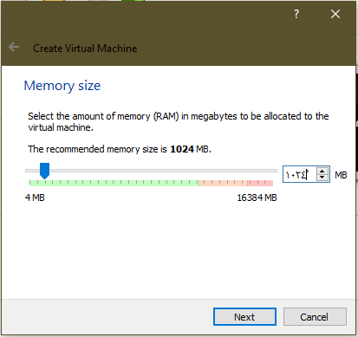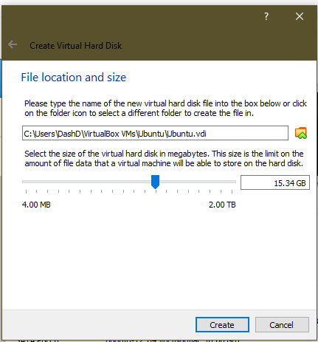

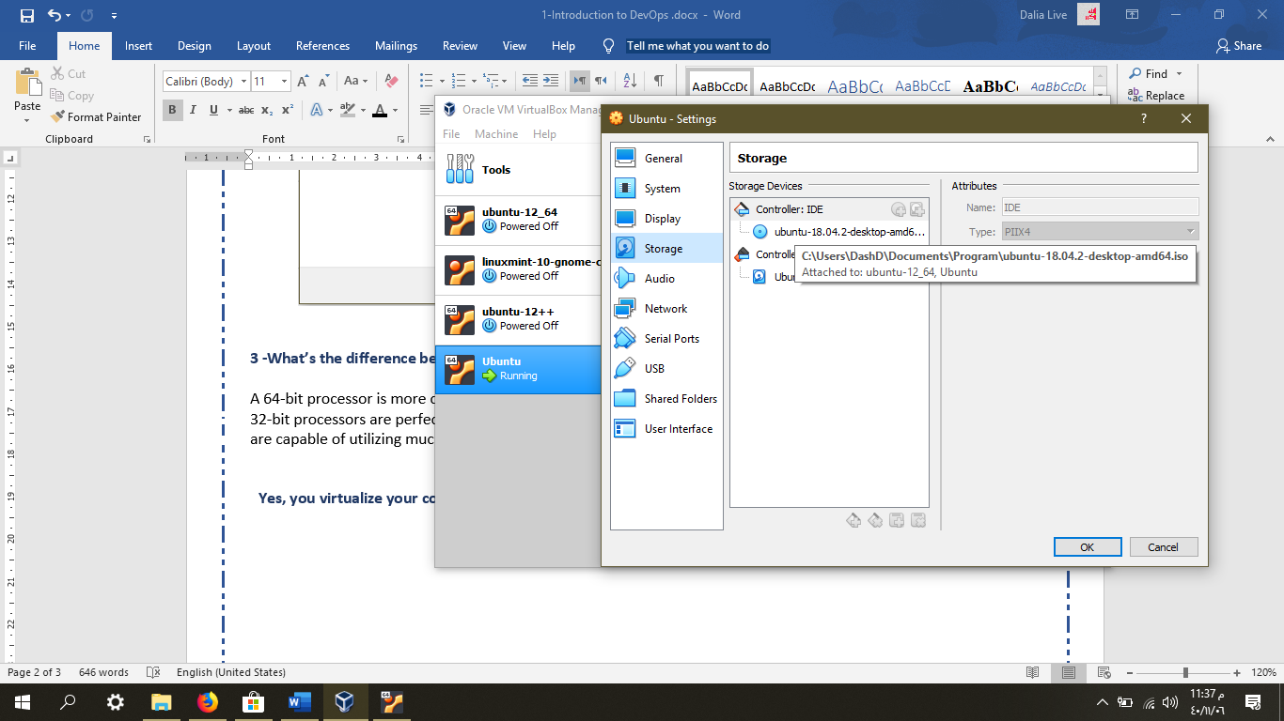

**3 -What’s the difference between x64 & x32 bit?**

A 64-bit processor is more capable than a 32-bit processor, because it can handle more data at once **>**

32-bit processors are perfectly capable of handling a limited amount of RAM (win 4GB or less), and 64-bit processors are capable of utilizing much more.[5]

**Task #3  
Yes, you virtualize your computer, what’s next. Experience the fun part of installing multiple operating system in your single computer.   
-Create another Linux VMs in virtualbox.  
1- Maybe use another Linux distribution? (e.g. Fedora)**

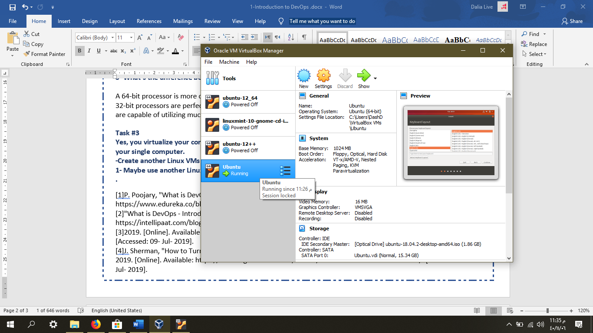

**----------------------------------------------------------------------------------------------------------------**

[1]P. Poojary, "What is DevOps - Facebook's UseCase | DevOps Tools | Edureka", *Edureka*, 2019. [Online]. Available: https://www.edureka.co/blog/what-is-devops/. [Accessed: 09- Jul- 2019].

[2]"What is DevOps - Introduction to DevOps Architecture & Benefits", *Intellipaat Blog*, 2019. [Online]. Available: https://intellipaat.com/blog/what-is-devops/. [Accessed: 09- Jul- 2019].

[3]2019. [Online]. Available: https://www.techopedia.com/definition/26629/guest-virtual-machine-guest-vm. [Accessed: 09- Jul- 2019].

[4]J. Sherman, "How to Turn Your Android Device into a Web, FTP, or Media Server | Digital Trends", *Digital Trends*, 2019. [Online]. Available: https://www.digitaltrends.com/mobile/how-to-make-an-android-server/. [Accessed: 09- Jul- 2019].

[5]J. Martindale, "Here's why 64-bit (not 32-bit) dominates modern computing", *Digital Trends*, 2019. [Online]. Available: https://www.digitaltrends.com/computing/32-bit-vs-64-bit-operating-systems/. [Accessed: 09- Jul- 2019].